ScreenShot:

1. Create Dropbox project in AppConsole.

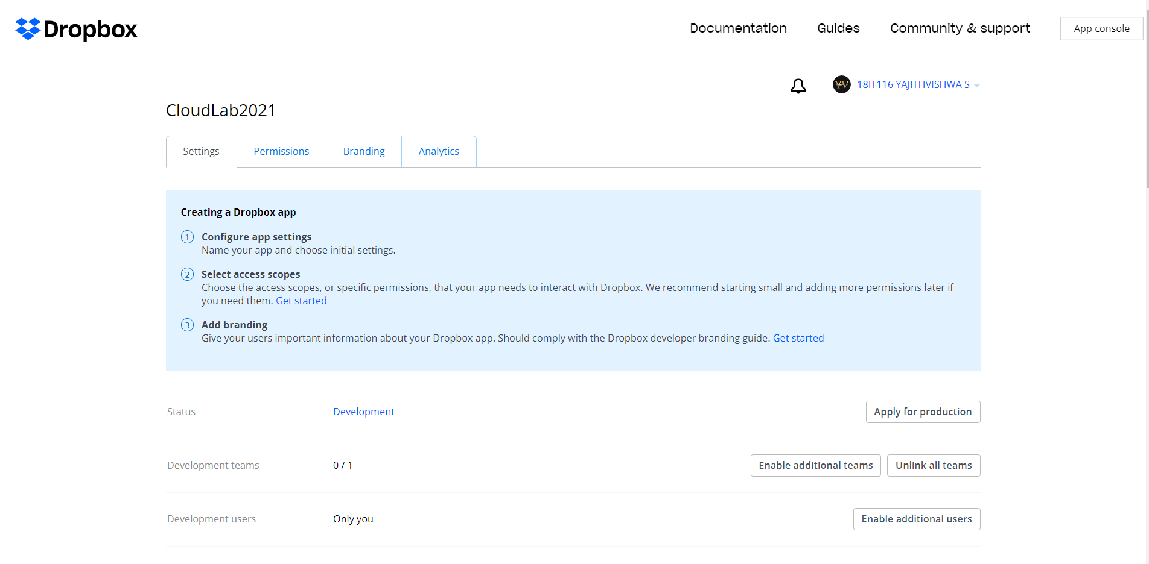

1. Select the project in Drop box app console.

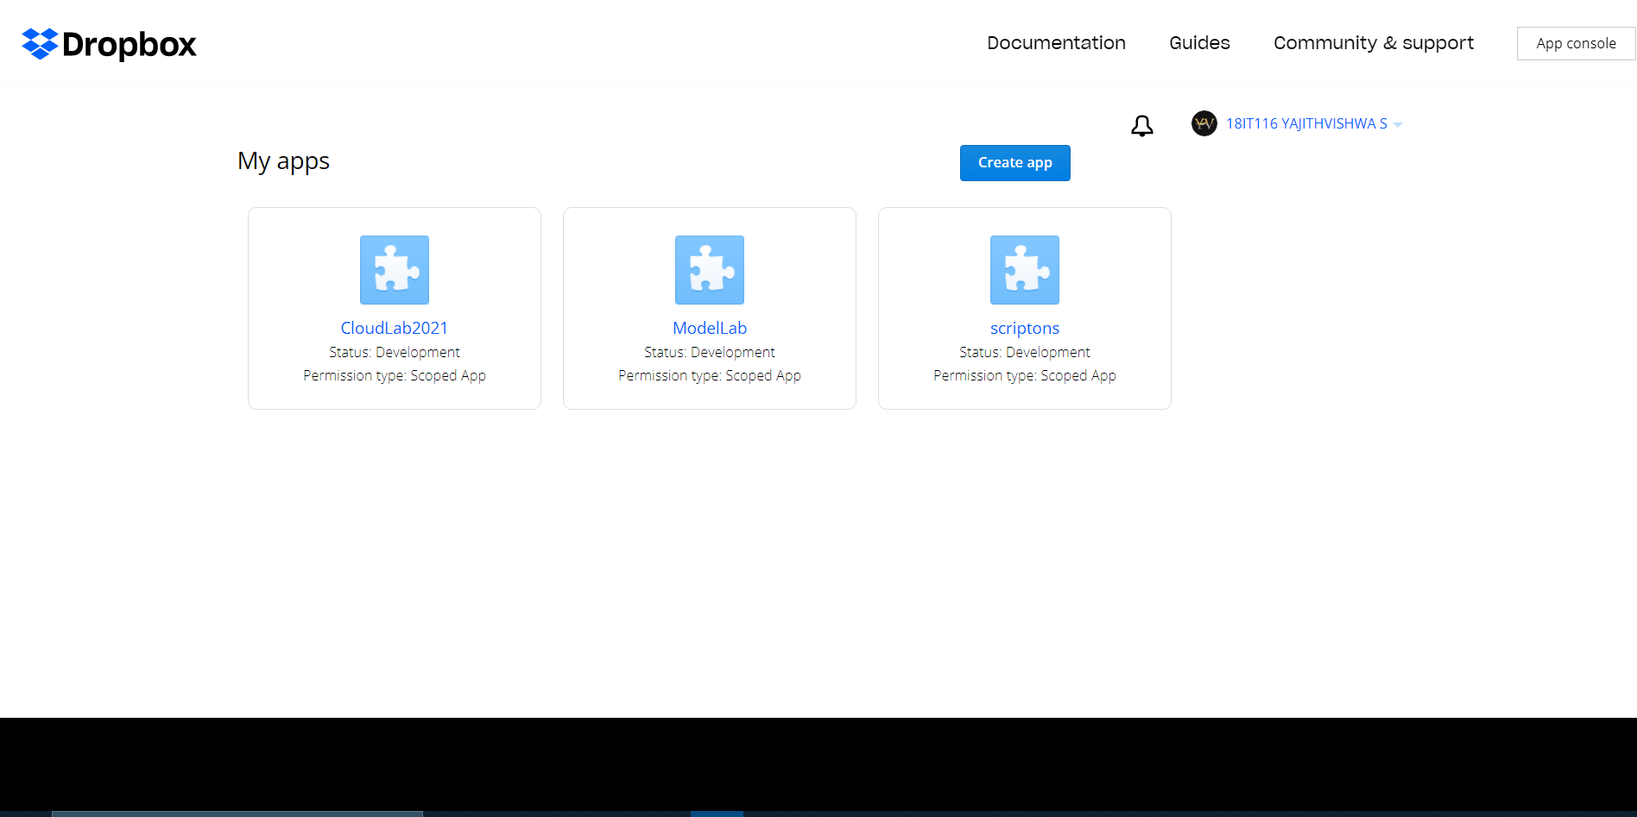

1. Enable Permission.

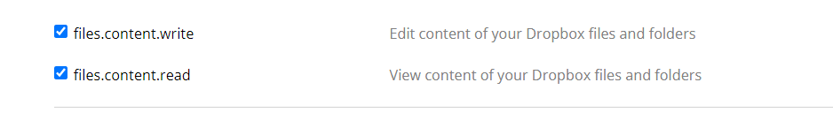

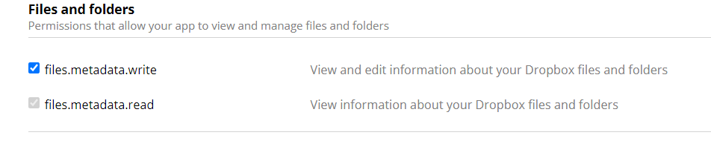

1. Clone Java SDK drop box project from github

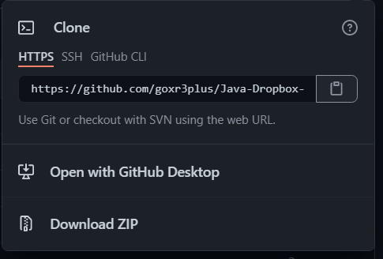

1. Store in a Folder.

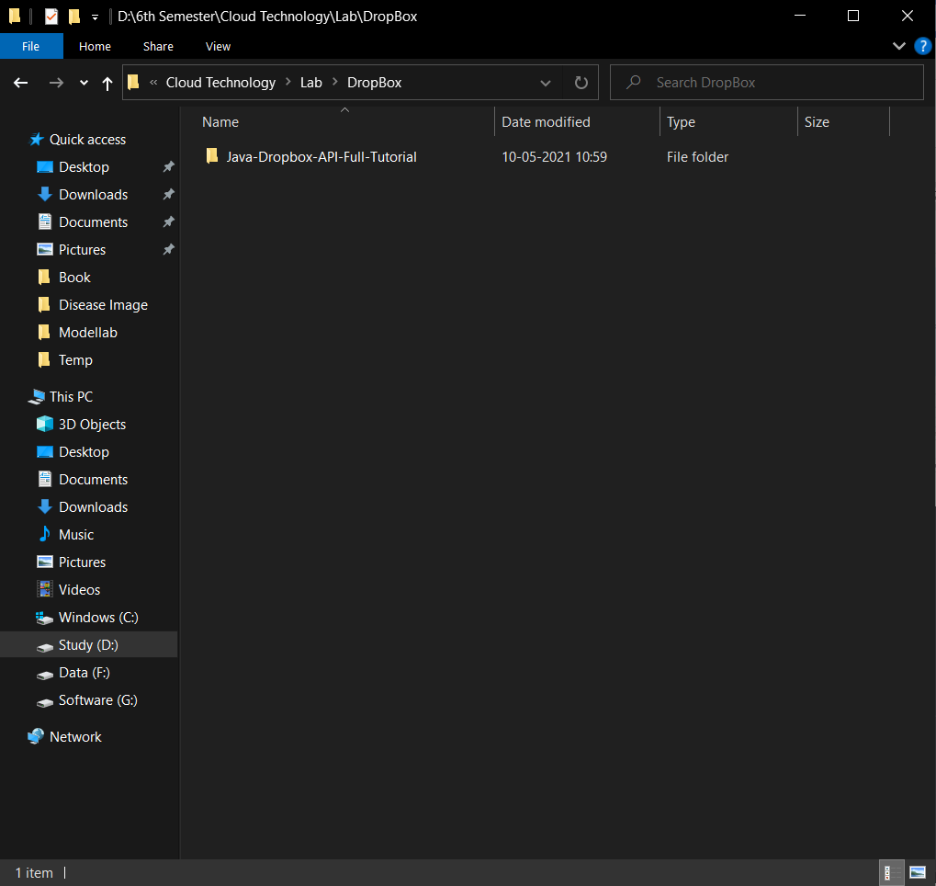

1. Do mvn clean package in downloaded folder.

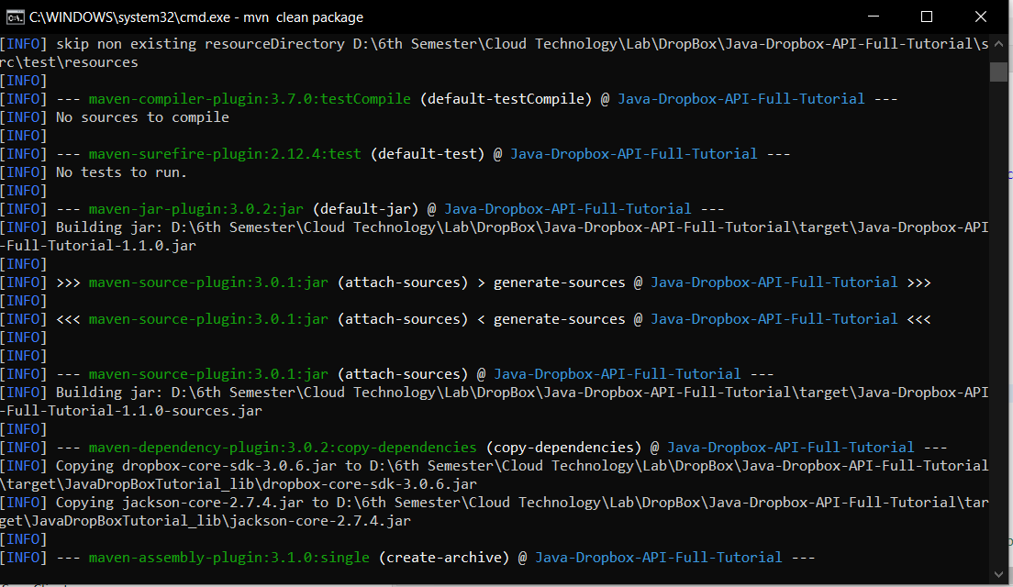

1. Generate Access Token in drop box console.

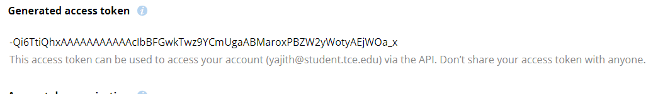

1. Change Access Token and Project Name in java code.

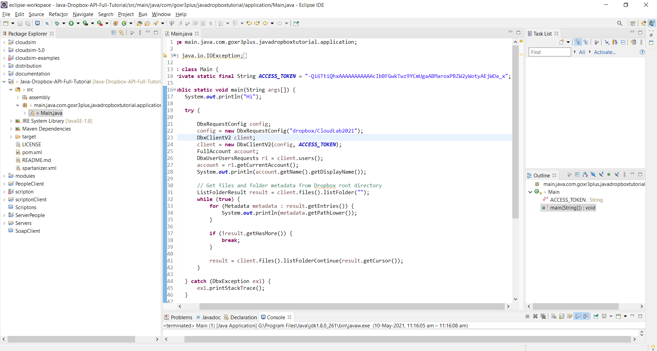

1. Click Run and see console for output.

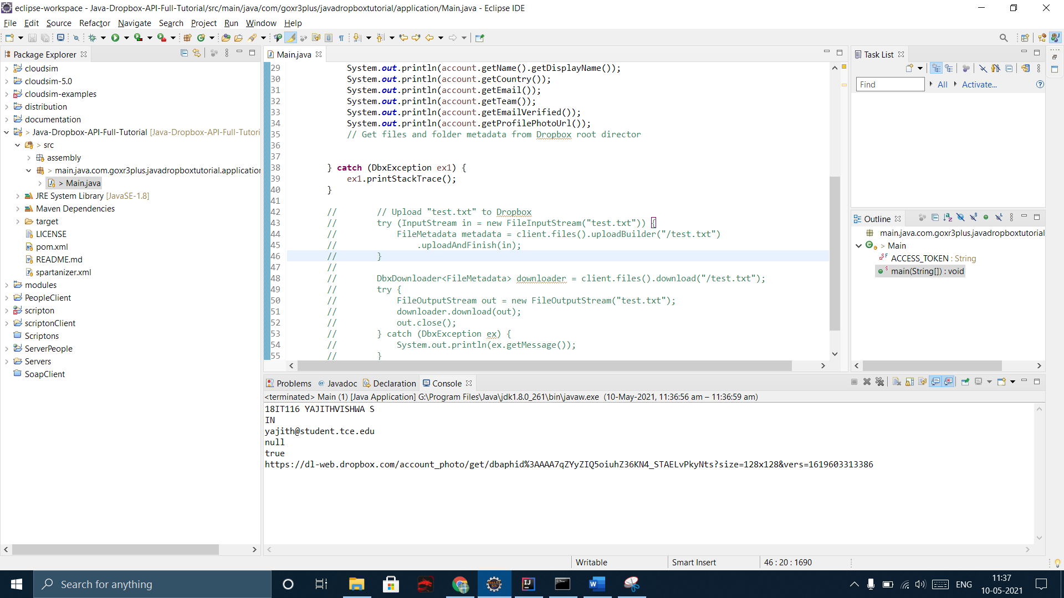

1. Upload a file in drop box .

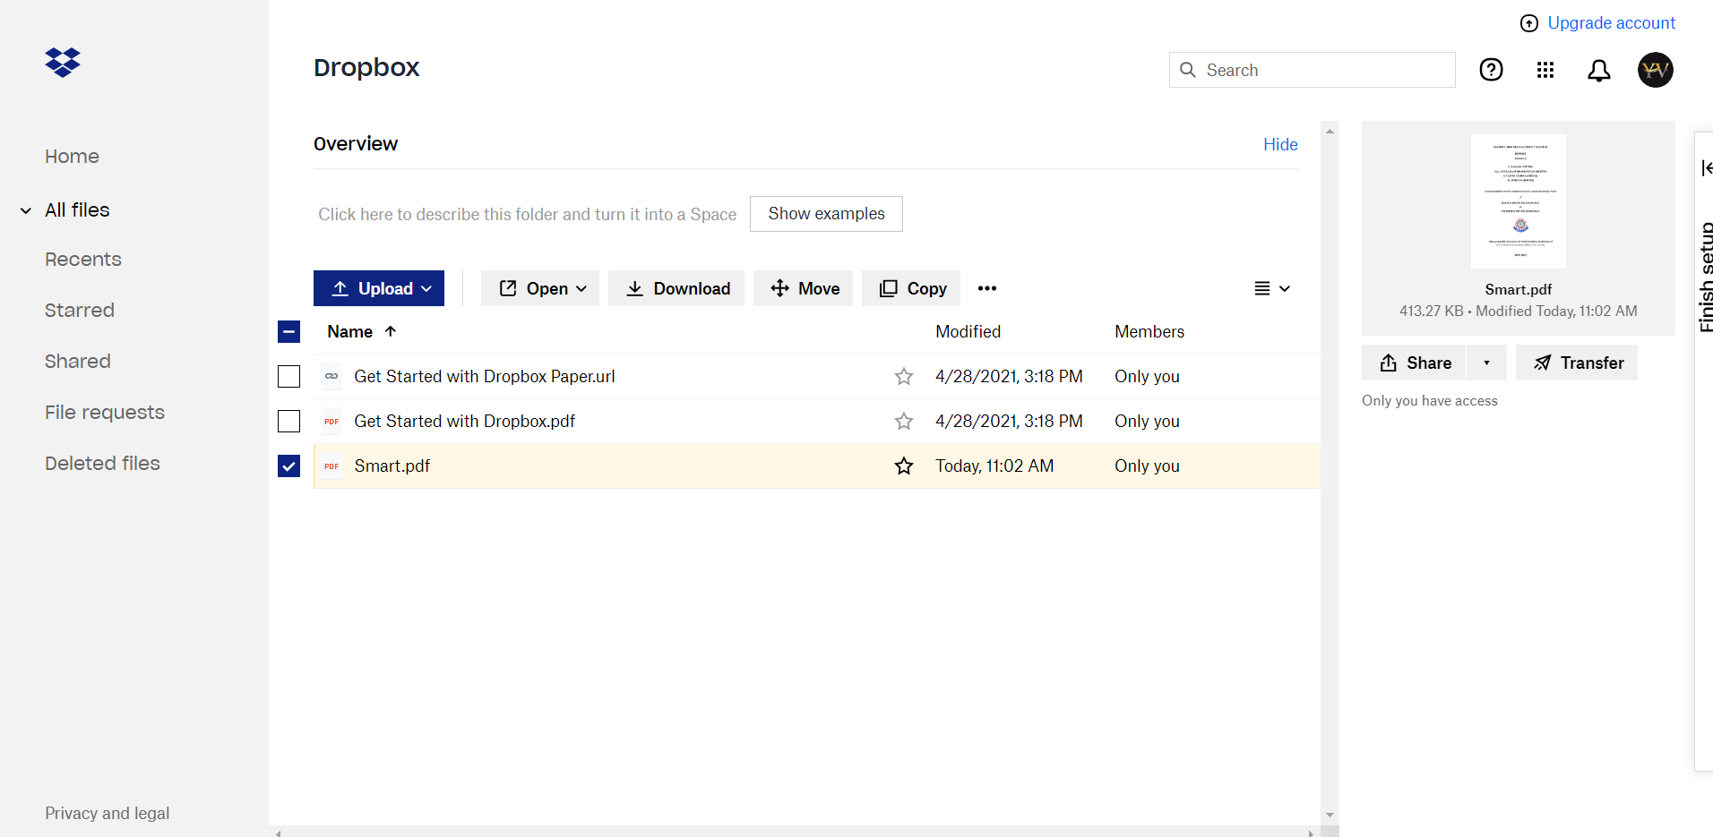

1. Download a pdf file from drop box and store in project file folder.

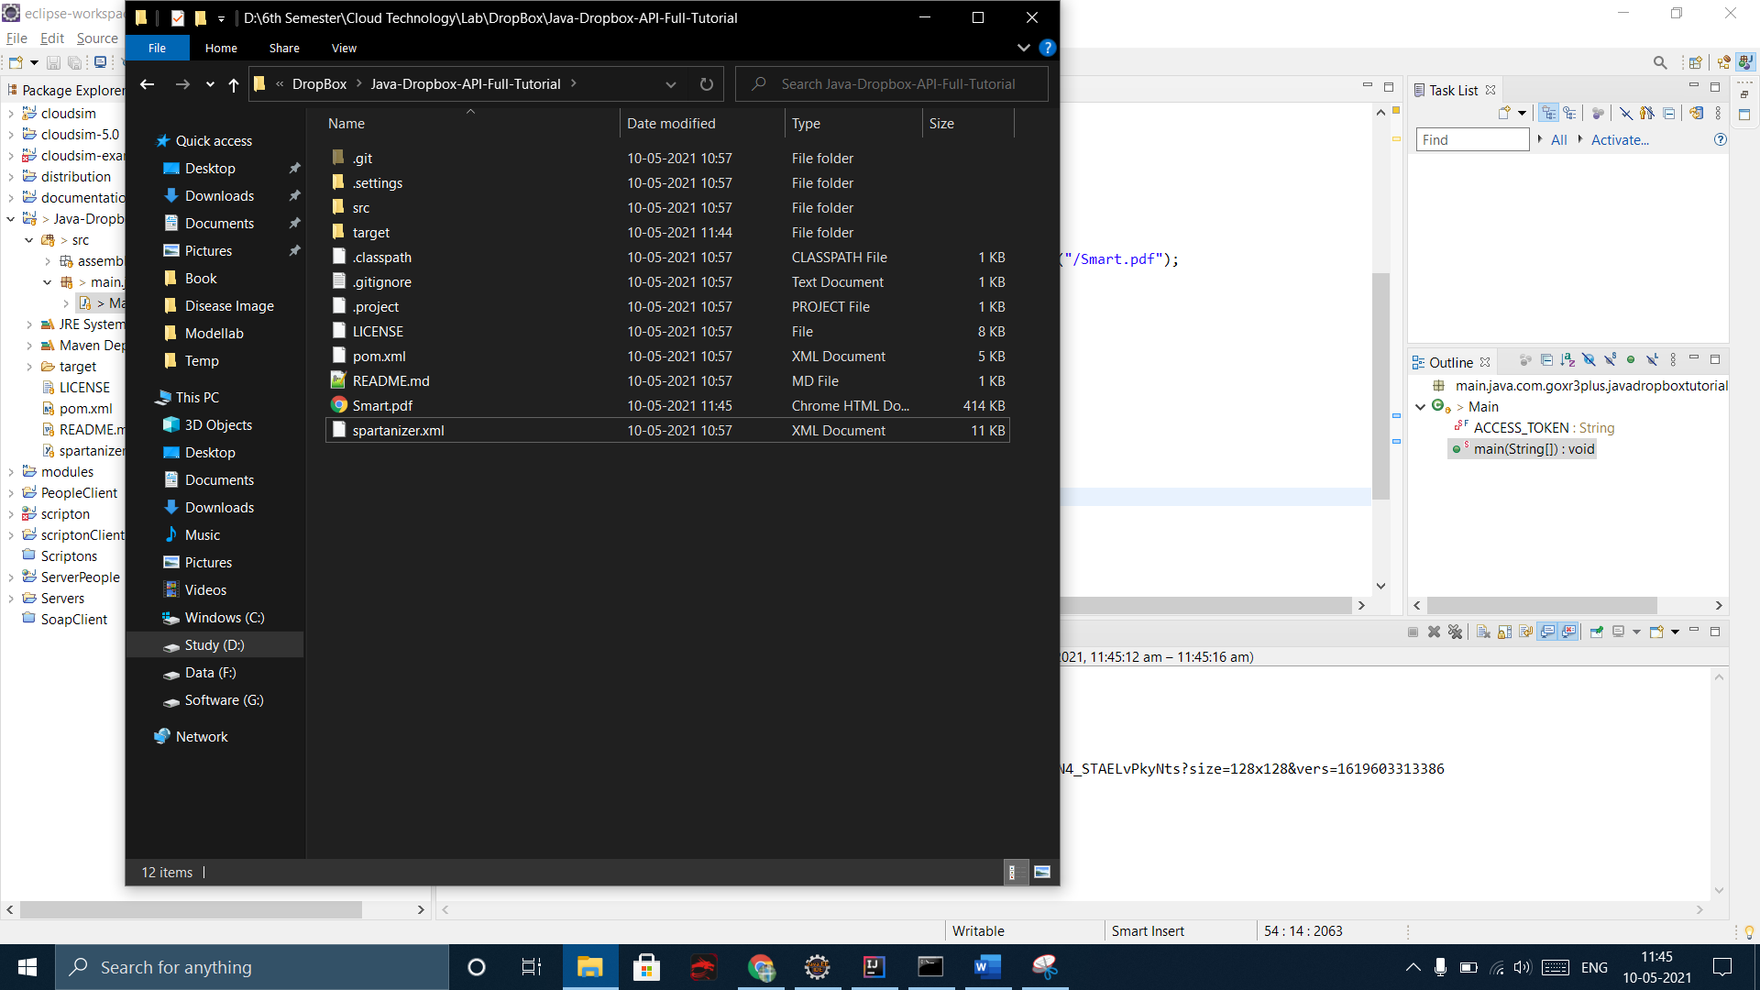

Result:

To implement Storage as Service with drop box using java is verified.